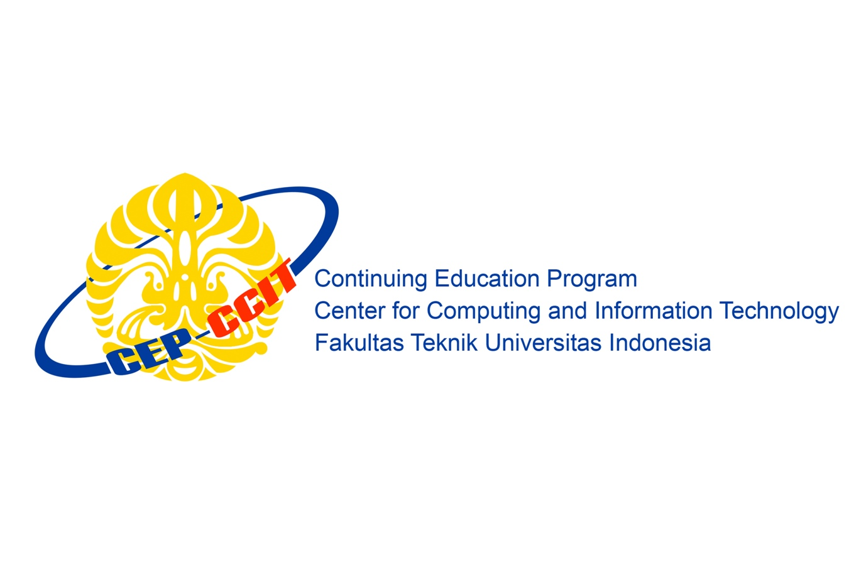**(PROJECT)**

**JAVA IN GITHUB AND JENKINS**

**Faculty:**

**Mr. Listyo Edi Prabowo S.T**

Created by:

**Ferdiansyah ( 1820010074 )**

**M. Dani Setiawan**

Class:

3SC5

**Continuing Education Program for Computing and Information Technology**

**Faculty of Engineering, University of Indonesia**

**2019**